**ĐẠI HỌC BÁCH KHOA HÀ NỘI  
TRƯỜNG CÔNG NGHỆ THÔNG TIN VÀ TRUYỀN THÔNG**

----- 🙡 🕮 🙣 -----



BÁO CÁO THỰC HÀNH  
IT3103 – 744529 - 2024.1

BÀI THỰC HÀNH 5

Họ và tên sinh viên: Đoàn Nhật Quang

MSSV: 20225911

Lớp: Việt Nhật 05 – K67

GVHD: Lê Thị Hoa

HTGD: Bùi Trọng Dũng

Hà Nội 12/2024

BÁO CÁO THỰC HÀNH LAB 5

LẬP TRÌNH HƯỚNG ĐỐI TƯỢNG

Contents

1. Swing components 4

1.1 AWTAccumulator 4

1.2 SwingAccumulator 6

2. Organizing Swing components with Layout Managers 8

2.1 Code 8

2.2. Demo 10

3. Create a graphical user interface for AIMS with Swing 12

3.1 Create class StoreScreen 12

3.2. Create class MediaStore 16

3.3. Demo 17

4. JavaFX API 20

4.1 Create class Painter 20

4.2 Create Painter.fxml 21

4.3. Create Painter Controller 22

4.4. Demo 23

5. View Cart Screen 25

5.1 Create Cart.fxml 25

5.2 Create class CartScreen 27

5.3 Create class CartSceenController 28

5.4 Demo 32

6. Updating buttons based on selected item in TableView – ChangeListener 33

6.1 Edit class CartScreenController 33

6.2 Demo 35

7. Deleting a media 36

7.1 Code 36

7.2 Demo 36

8. Filter items in cart – FilteredList 38

8.1 Code 38

8.2 Demo 39

9. Complete the Aims GUI application 41

9.1 Update StoreScreen with AddItemToStoreScreen, AddBookStoreScreen, AddCDStoreScreen, AddDVDStoreScreen 41

9.2 Demo 46

10. Exception 49

10.1 Class PlayerException 49

10.2 Raise the PlayerException in the play() method 49

10.3 Update play() in the Playable interface 49

10.4 Update play() in CompactDisc 50

11. Modify the equals() method of Media class 50

12. Usecase Diagram 51

13. Class Diagram 52

Mục lục hình ảnh

Hình 1: Source code of AWTAccumulator 4

Hình 2: Demo of AWTAccumulator 5

Hình 3: Source code of SwingAccumulator 6

Hình 4: Demo of SwingAccumulator 7

Hình 5: Source code of NumberGrid 1 8

Hình 6: Source code of NumberGrid 2 9

Hình 7: Demo buttons 0 – 9 10

Hình 8: Demo button DEL 10

Hình 9: Demo button C 11

Hình 10: Class StoreScreen 1 12

Hình 11: Class StoreScreen 2 13

Hình 12: Class StoreScreen 3 14

Hình 13: Class StoreScreen 4 15

Hình 14: Class MediaStore 1 16

Hình 15: Class MediaStore 2 17

Hình 16: Store Screen 18

Hình 17: Demo Add to cart button 19

Hình 18: Demo Play button 19

Hình 19: Class Painter 20

Hình 20: Painter.fxml 1 21

Hình 21: Painter.fxml 2 21

Hình 22: Classm PainterController 22

Hình 23: Use pen 23

Hình 24: Use eraser 23

Hình 25: Use Clear 24

Hình 26: Cart.fxml 1 25

Hình 27: Cart.fxml 2 25

Hình 28: Cart.fxml 3 26

Hình 29: Cart.fxml 4 26

Hình 30: Class CartScreen 1 27

Hình 31: Class CartScreen 2 27

Hình 32: Class CartSceenController 1 28

Hình 33: Class CartScreenController 2 29

Hình 34: Class CartScreenController 3 30

Hình 35: Class CartScreenController 4 31

Hình 36: Demo CartScreen 32

Hình 37: Edit class CartScreenController 1 33

Hình 38: Edit class CartScreenController 2 34

Hình 39: Demo media playable 35

Hình 40: Demo media unplayable 35

Hình 41: Code Delete a media 36

Hình 42: Demo delete Media (before) 36

Hình 43: Demo delete Media (after) 37

Hình 44: Filter items in cart 38

Hình 45: Demo before filtered 39

Hình 46: Demo filtered by ID 39

Hình 47: Demo filtered by Title 40

Hình 48: Update StoreScreen 41

Hình 49: Abstract class AddItemsToStore 42

Hình 50: Class AddDVDStoreScreen 43

Hình 51: Class AddCDStoreScreen 44

Hình 52: Class AddBookStoreScreen 45

Hình 53: Add Book (before) 46

Hình 54: Add Book (after) 46

Hình 55: Add CD (before) 47

Hình 56: Add CD (after) 47

Hình 57: Add DVD (before) 48

Hình 58: Add DVD (after) 48

Hình 59: Class PlayerException 49

Hình 60: Update play() in DigitalVideoDisc 49

Hình 61: Update play() in Track 49

Hình 62: Update play() in the Playable interface 49

Hình 63: Update play() in CompactDisc 50

Hình 64: Modify the equals() method of Media class 50

Hình 65: Usecase Diagram 51

Hình 66: Class Diagram 52

# Swing components

## AWTAccumulator

Hình 1: Source code of AWTAccumulator

Hình 2: Demo of AWTAccumulator

## SwingAccumulator

Hình 3: Source code of SwingAccumulator

Hình 4: Demo of SwingAccumulator

# Organizing Swing components with Layout Managers

## Code

Hình 5: Source code of NumberGrid 1

Hình 6: Source code of NumberGrid 2

## 2.2. Demo

Hình 7: Demo buttons 0 – 9

Hình 8: Demo button DEL

Hình 9: Demo button C

# Create a graphical user interface for AIMS with Swing

## Create class StoreScreen

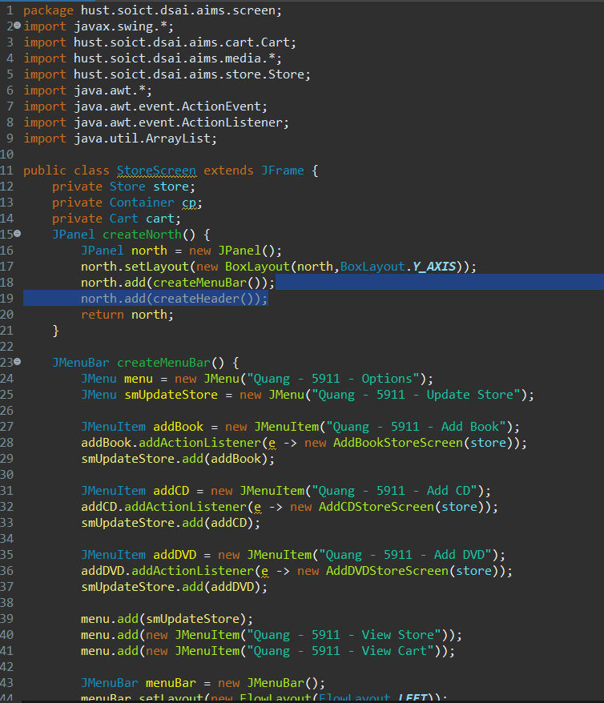

Hình 10: Class StoreScreen 1

Hình 11: Class StoreScreen 2

Hình 12: Class StoreScreen 3

Hình 13: Class StoreScreen 4

## 3.2. Create class MediaStore

Hình 14: Class MediaStore 1

Hình 15: Class MediaStore 2

## 3.3. Demo

Hình 16: Store Screen

Hình 17: Demo Add to cart button

Hình 18: Demo Play button

# JavaFX API

## Create class Painter

Hình 19: Class Painter

## Create Painter.fxml

Hình 20: Painter.fxml 1

Hình 21: Painter.fxml 2

## 4.3. Create Painter Controller

Hình 22: Classm PainterController

## 4.4. Demo

Hình 23: Use pen

Hình 24: Use eraser

Hình 25: Use Clear

# View Cart Screen

## Create Cart.fxml

Hình 26: Cart.fxml 1

Hình 27: Cart.fxml 2

Hình 28: Cart.fxml 3

Hình 29: Cart.fxml 4

## Create class CartScreen

Hình 30: Class CartScreen 1

Hình 31: Class CartScreen 2

## Create class CartSceenController

Hình 32: Class CartSceenController 1

Hình 33: Class CartScreenController 2

Hình 34: Class CartScreenController 3

Hình 35: Class CartScreenController 4

## Demo

Hình 36: Demo CartScreen

# Updating buttons based on selected item in TableView – ChangeListener

## Edit class CartScreenController

Hình 37: Edit class CartScreenController 1

Hình 38: Edit class CartScreenController 2

## Demo

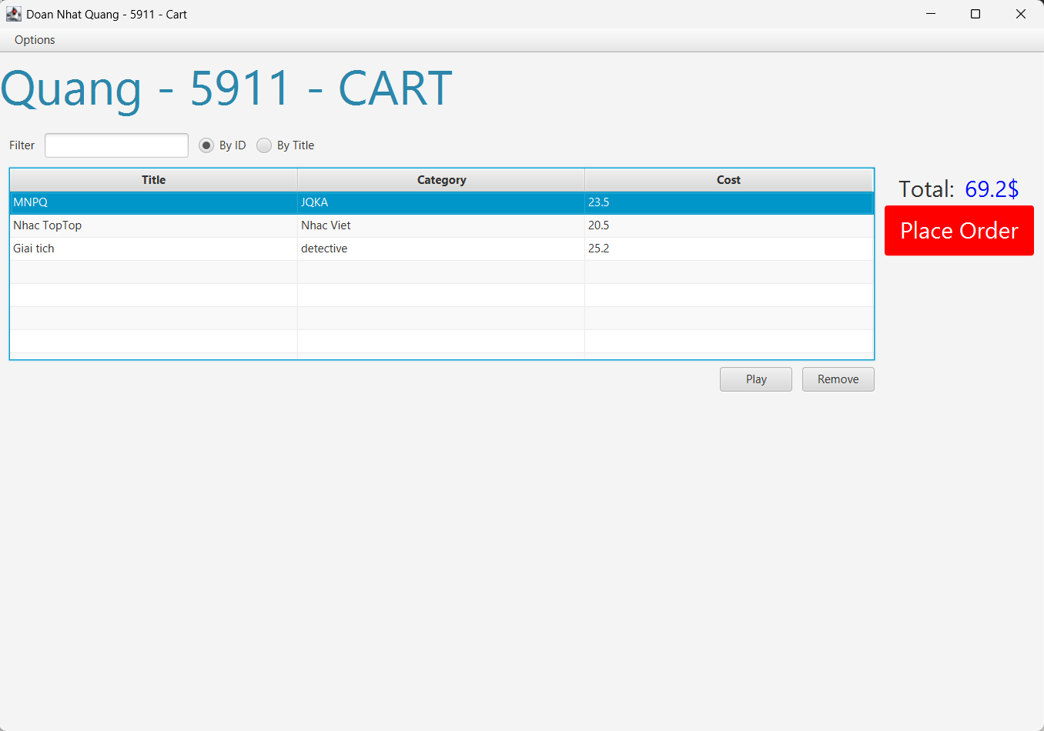

Hình 39: Demo media playable

Hình 40: Demo media unplayable

# Deleting a media

## Code

Hình 41: Code Delete a media

## Demo

Hình 42: Demo delete Media (before)

Hình 43: Demo delete Media (after)

# Filter items in cart – FilteredList

## Code

Hình 44: Filter items in cart

## Demo

Hình 45: Demo before filtered

Hình 46: Demo filtered by ID

Hình 47: Demo filtered by Title

# Complete the Aims GUI application

## Update StoreScreen with AddItemToStoreScreen, AddBookStoreScreen, AddCDStoreScreen, AddDVDStoreScreen

Hình 48: Update StoreScreen

Hình 49: Abstract class AddItemsToStore

Hình 50: Class AddDVDStoreScreen

Hình 51: Class AddCDStoreScreen

Hình 52: Class AddBookStoreScreen

## Demo

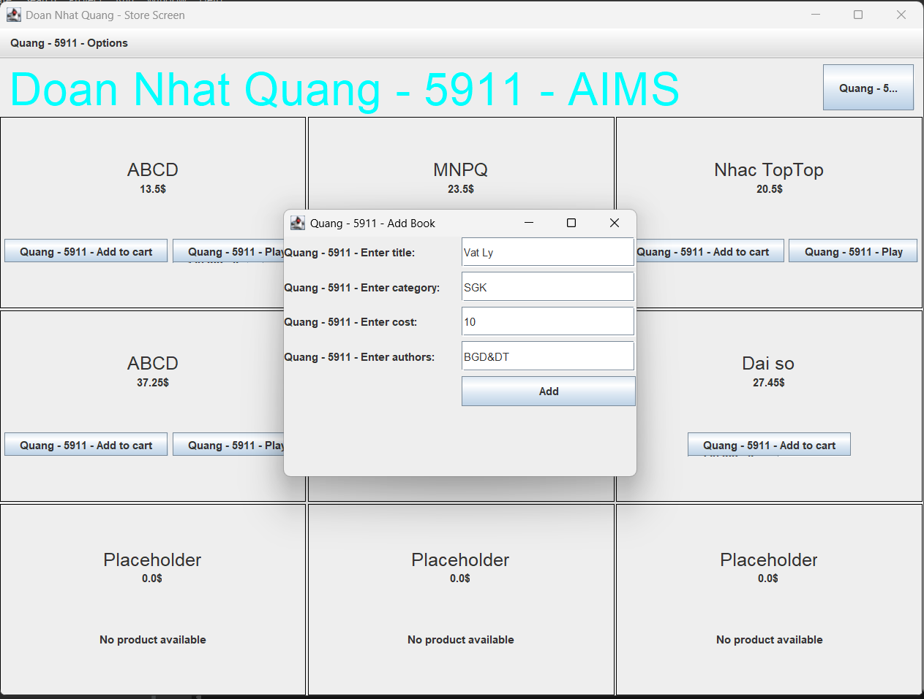

Hình 53: Add Book (before)

Hình 54: Add Book (after)

Hình 55: Add CD (before)

Hình 56: Add CD (after)

Hình 57: Add DVD (before)

Hình 58: Add DVD (after)

# Exception

## Class PlayerException

Hình 59: Class PlayerException

## Raise the PlayerException in the play() method

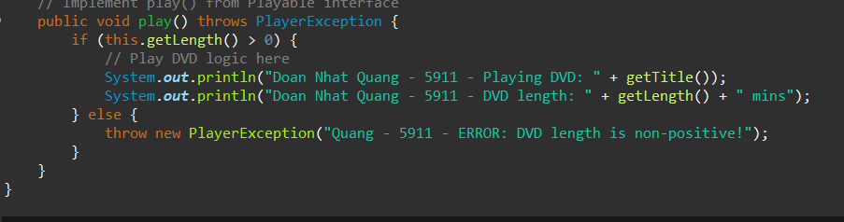

Hình 60: Update play() in DigitalVideoDisc

Hình 61: Update play() in Track

## Update play() in the Playable interface

Hình 62: Update play() in the Playable interface

## Update play() in CompactDisc

Hình 63: Update play() in CompactDisc

# Modify the equals() method of Media class

Hình 64: Modify the equals() method of Media class

# Usecase Diagram

Hình 65: Usecase Diagram

# Class Diagram

Hình 66: Class Diagram